AZURE BUSINESS CONTINUITY CENTER

Azure Business Continuity Center : Azure Business Continuity Center (ABC) is a cloud-native, unified management platform for all your business continuity and disaster recovery (BCDR) protection needs.

Uses : The Azure Business Continuity Center is a unified management platform for protecting and recovering resources across various environments.

You can use it to govern, monitor, operate, and enhance your business continuity and disaster recovery (BCDR) strategy at scale.

Why should I use Azure Business Continuity Center?

* Single pane of glass : Gain a unified view of all your BCDR operations, covering Azure, hybrid, and on-premises environments. It consolidates information from Azure Backup and Azure Site Recovery.
* Compliance audits : Generate reports and use built-in Azure Policies for BCDR management to provide evidence of compliance during audits.

Unified monitoring : Centrally track all backup and replication jobs, as well as alerts, across multiple subscriptions, regions, and vaults.

Protection status overview : View the protection status of your entire BCDR estate to easily identify unprotected resources. The center provides recommendations and actions to improve coverage.

Tenant Management Architecture : A tenant management architecture on Azure is a design approach for building and managing multi-tenant solutions, such as Software as a Service (SaaS) applications, or for enterprises that use multiple Microsoft Entra ID (formerly Azure AD) tenants.

Microsoft Azure Lighthouse : Azure Lighthouse is a management service that enables cross-tenant management, allowing service providers and large enterprises to manage multiple Azure environments from a single, centralized control plane.

Azure Site Recovery : Azure Site Recovery (ASR) is a disaster recovery as a service (DRaaS) solution that orchestrates the replication, failover, and failback of workloads running on-premises or in Azure.

How to replicate two servers from one region to another region?

BUSINESS CONTINUITY CENTER

App server1 App server 2

Backup service vault

Replication virtual Machines

from one region1 to region 2

Resource Group Resource Group 2

Region 1 Region 2

East US West US

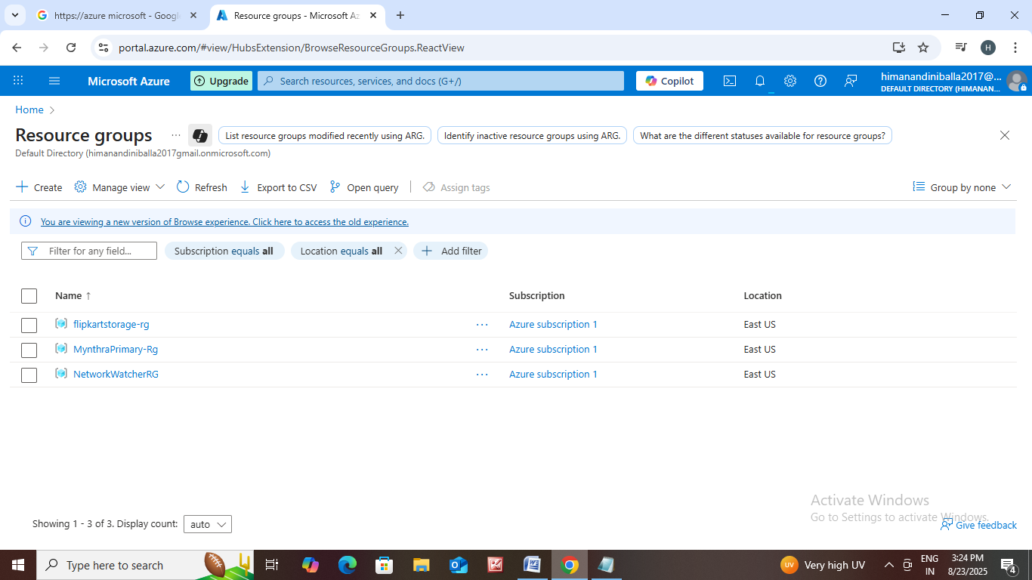Go to https://azure Microsoft.

RESOURCE GROUP1

• Go to home click on Resource group.

• Then click on create.

• The page is open enter resource group

name : MynthraPrimary-Rg.

• Region : East us.

• Then click on next.

• Name that tags.

• Then click create.

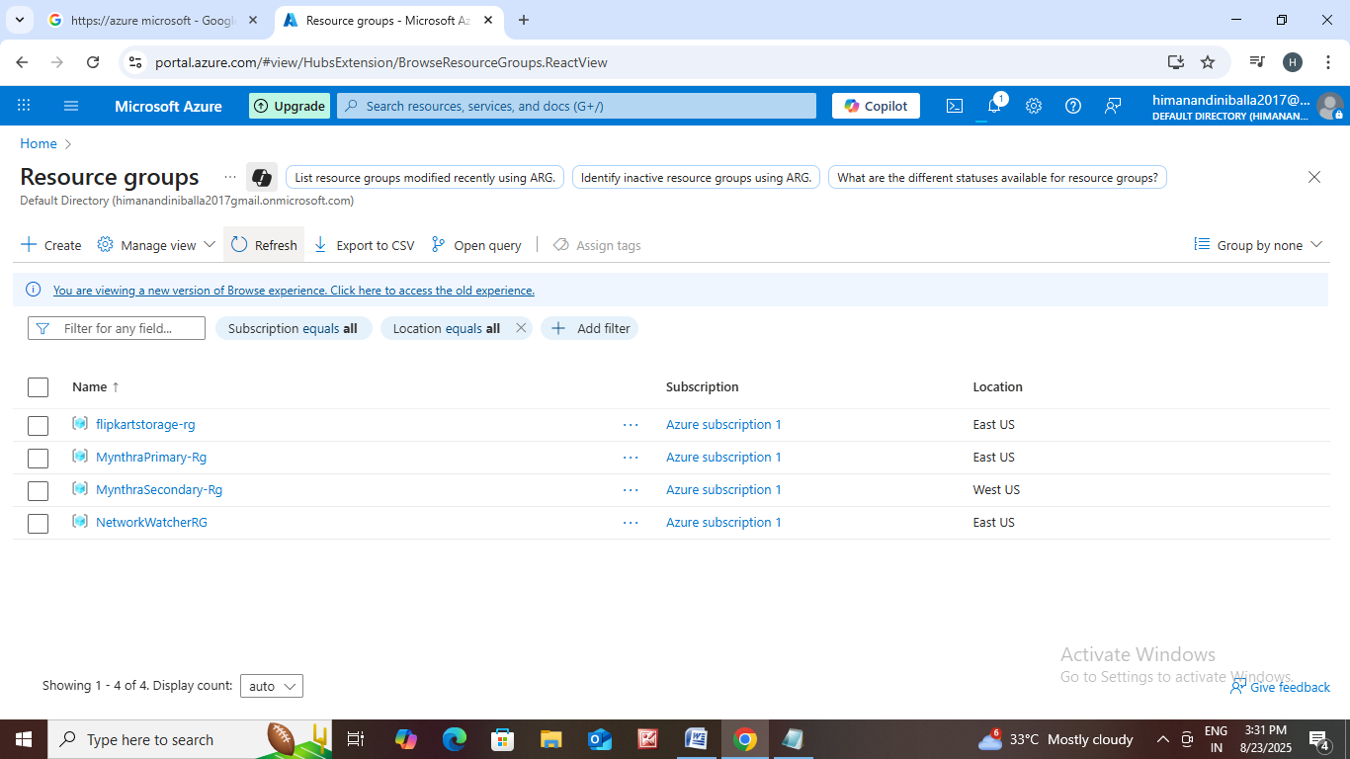RESOURCE GROUP 2

* Go to home click on Resource group.
* Then click on create.
* The page is open enter resource group name : MynthraSecondary-Rg.
* Region : East us.
* Then click on next.
* Name that tags.
* Then click create.

Next Let us Create virtual machines.

VIRTUAL MACHINE 1

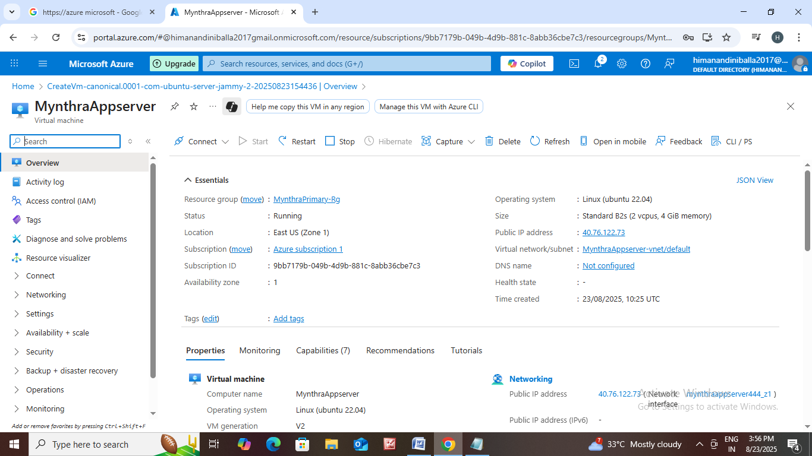• Go to home and search for virtual machine.

• The page is open then click on create.

• Resource Group name : MynthraPrimary-Rg.

• Virtual machine name : MynthraAppserver.

• Image name : Ubuntu server 22.04 LTS.

• Choose size and enter your username and password.

• Then click next.

• Choose disks, networking options.

• Then click on create.

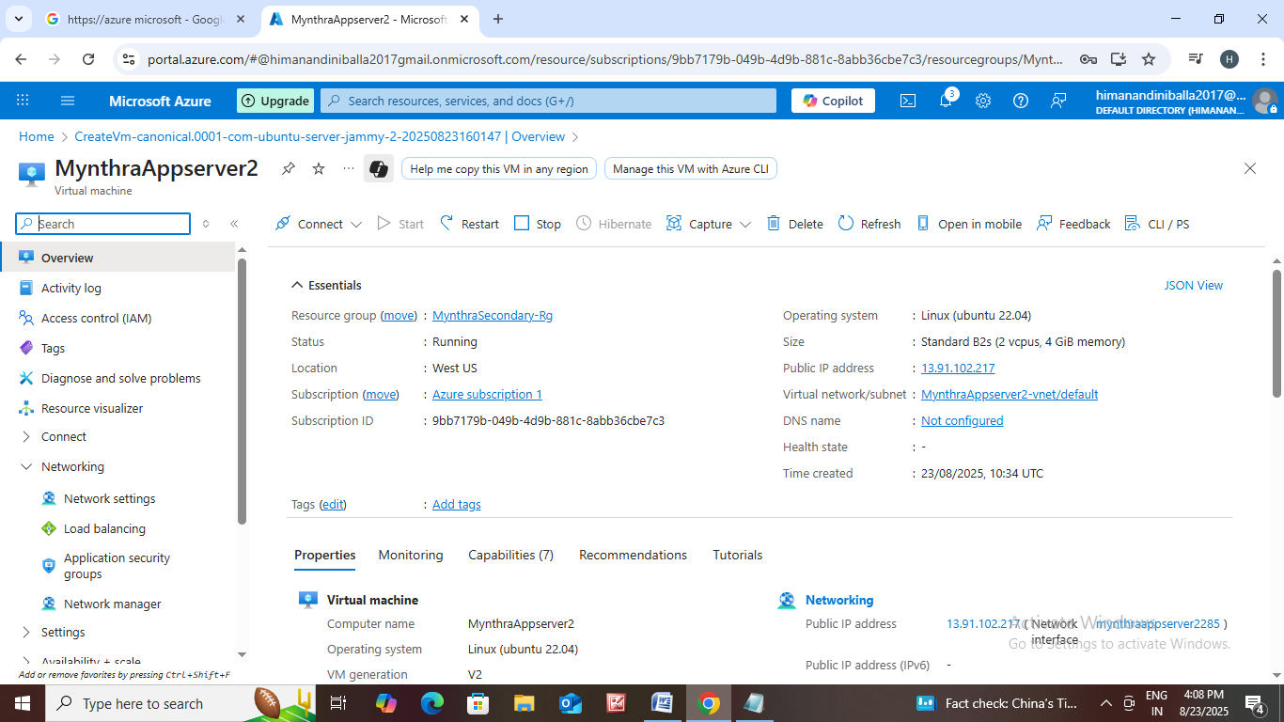

VIRTUAL MACHINE 2

• Go to home and search for virtual machine.

• The page is open then click on create.

• Resource Group name : MynthraSecondary-Rg.

• Virtual machine name : MynthraAppserver2.

• Image name : Ubuntu server 22.04 LTS.

• Choose size and enter your username and password.

• Then click next.

• Choose disks, networking options.

• Then click on create

\* Go to mynthraappserver2 overview click on Network settings.

\* After that cliock on port rule.

\* Select inbound port rule.

\* In the destination port add \* .

\* Then add the rule.

* Go to home search Business Continuity Center in search bar.
* After that the page is open.
* Click on protected items.
* Then click on configure protection.
* Resources managed by : Azure.
* Datasource type : Azure virtualmachine
* Solution : Azure site recovery.
* Then click on continue.
* Next create Recovery service vault.
* Enter second resourcegroup name.
* Enter vault name Mynthraservicevault.
* Then click on next enter backup storage redundancy name :Geo redundant.
* Cross region enable.
* Name that tags.Then click on create.
* Next go to previous page of configure protection.
* Select recovery service vault name.
* Then click on next enter source resource group name :Mynthraprimary-rg.
* Virtual machine deployment model : Resource manager.
* Disaster recovery between availability zones : No.
* Select two virtual machines and then click on next.
* Enter your target location and resource group :West Us and MynthraSecondary-Rg.
* Then click on Enable Replication.